

Templefield Lower School
Science Policy

Last reviewed on: November 2023

Last reviewed by: S. Ashfield
Templefield Lower School
A POLICY FOR THE TEACHING AND LEARNING OF SCIENCE

PHILOSOPHY
We believe that as our children are growing up in a technological and scientific society, we have a responsibility to teach science in a way that excites and motivates each pupil. The children should be given opportunities to develop their science capital, which is an essential contribution to learning about the diversity and wonder of the wider world. They will achieve this by taking part in activities that promote experimentation, discovery, investigation, observation and discussion.

We believe that all pupils should have regular access to science appropriate to their age and stage of development, and that emphasis should be given to the teaching of this core subject.

OUR VISION OF SCIENCE
At Templefield Lower School, we aim to deliver a Science curriculum that is hands on, practical and investigative, and that enhances every child’s Science capital by providing them with a range of experiences.

PRINCIPLES TEACHING OF SCIENCE
The below visions will be embedded in Science teaching and learning across the school. They will be on display to the adults and children in every classroom. Teachers and children will work together to ensure that all Science lessons follow the principles.
Science learning in our school is good when we:
- Listen to others’ ideas and are challenged.
- Learn by asking and answering questions.
- Learn more about our topics.
- Use scientific vocabulary
- Find out about the world around us and how things work.
- Do things that are fun and exciting.
- Take part in experiments and investigations.
- Include everyone in our learning.
- Can learn outdoors.

TEACHING AND LEARNING
To achieve these principles, all pupils will be given opportunities to:

- Develop scientific understanding using first-hand experience.
- Use ICT to collect, store, retrieve and present information.
- Relate work in science to everyday life.
- Consider simple scientific ideas, collect evidence and test hypotheses.
- Communicate scientific observations and ideas using subject specific vocabulary.
- Present information in a variety of ways including drawings, charts, tables, orally and in writing.
- Progress to using standard unit of measurement and graphs to present information.
- Learn how to use equipment correctly, how to predict potential hazards and behave in a safe way.

All pupils will follow the National Curriculum programme of study appropriate to their age, supported by the use of objectives on Insight (data tracker). The Science Progression of Skills document and the Science Curriculum map have been created to show the smooth transition of Science learning from Preschool to Year 4. Progression will be monitored termly by the Science subject leader. Learning objectives and success criterion are created to ensure that all areas of the curriculum for a specific year group are covered within the school year.
It is the responsibility of each teacher to ensure s/he is fully aware of the progressive nature of skill and concept acquisition in science so that pupils are provided with appropriately differentiated tasks. Teacher Assessment in Primary Science (TAPS) activities will be used as a way to assess the children’s achievement through differentiated experiments and investigations.
Teachers will use a range of teaching methods and styles to enable pupils to acquire knowledge, investigate independently, work collaboratively, discuss hypotheses, and experiment safely.

DISPLAY
Templefield Lower School’s display policy states that all displays should encourage pupils to have pride and confidence in their academic achievements. The school environment should be used to enrich children’s scientific learning and this can be achieved through the display of key vocabulary and experiments within classrooms. The standard of Science displays should be parallel to that of the Literacy and Numeracy displays.

PROGRAMME OF STUDY
To ensure full curriculum coverage, teachers will deliver the most current Science National Curriculum objectives, with support from objectives on Insight. Teachers will also ensure that they have consulted the progression of skills and curriculum map documents whilst planning the Science units.

Skills
Teachers will teach the following 6 enquiry approaches (see left) and the corresponding enquiry skills (see right), either directly or discretely, to enable pupils to work scientifically:
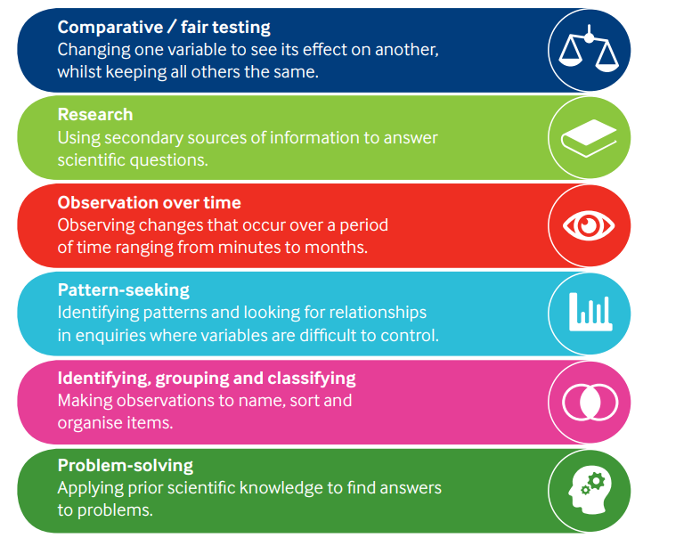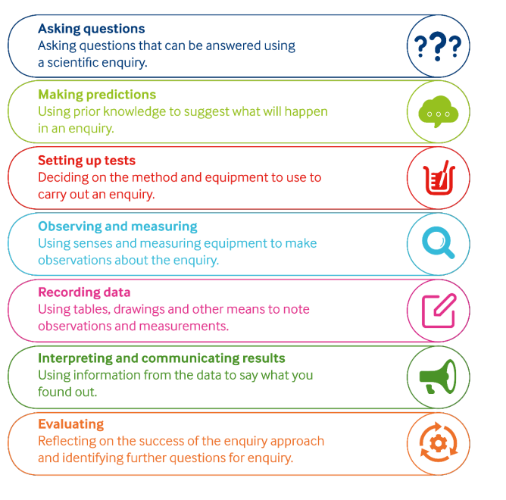

HEALTH AND SAFETY
It is the responsibility of the Science subject leader and the class teachers to ensure that all equipment and substances used in the teaching of Science are safe. Equipment should be checked each time it is used. Risk assessments should be carried out within weekly planning as appropriate, although this would be on a rare occasion.

In particular:
- Experiments involving the use of heat will be carried out by the teacher as demonstration only with pupils seated at a safe distance.
- Safety precautions will be taken if cutting equipment is being used.
- Teachers will follow health and safety guidelines when dealing with decomposing matter (refer to health and safety guidelines).
- Living creatures in the classroom will be looked after by an adult. Their treatment in school will be exemplary.

PLANNING AND ASSESSMENT
Teacher assessment plays an important part in Science. Effective planning will ensure that TAPS activities, Scientific enquiry approaches and the agreed Science vision and principles of learning have been considered when planning each Science lesson. When observing groups at work, teachers will note the precision of individual observations and each pupil’s ability to predict and evaluate.
Independent written work will provide opportunity for assessment against National Curriculum descriptors and Insight objectives. Written work will play its part in Science teaching alongside practical Science within Science lessons.
Precise records based on National Curriculum/Insight descriptors will enable teachers to record ongoing progress. Teachers will identify the next step each child needs to make to develop scientific skills and understanding, which will be passed on to the next teacher through data analysis at the end of each school year.

EQUAL OPPORTUNITIES
Science provides an ideal medium for the discovery of difference and diversity. Pupils will be encouraged to value all people and the potential of humanity.
Equal access to all scientific activities will be provided for all pupils regardless of gender, race, creed, special educational need or disability. Disabled pupils will be provided with the equipment and supervision necessary to enable them to get the full benefit from the teaching provided.

RESOURCES
Science resources will be stored in the delegated Science cupboard. Consumable items should be included in the main order at the start of the financial year; the subject leader requires all teachers to report any resources that need replacing or repurchasing. Larger items will be identified by the Science subject leader through the use of a resource audit and purchased with the knowledge and agreement of the head teacher.
Teachers wishing to extend the range of resources will discuss their ideas with the Science subject leader.
It is the responsibility of the Science subject leader to ensure that all resources are safe and in good working order.

SUCCESS CRITERIA
The success of this policy will be judged by:-

- The rate of progress made by pupils within EYFS, Key Stage 1 and Key Stage 2.
- Manageability within the classroom.
- Pupils’ enthusiasm for science.
- The availability and use of Science resources.
- The application of the Science vision and principles of learning.

The Science subject leader will use release time to observe and develop the delivery of science, the policy and principles in operation, and any resource implications.

