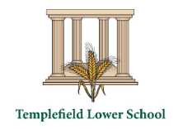
Science Newsletter
Summer 1 2024

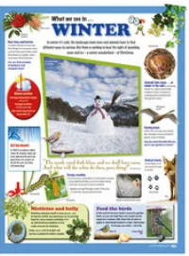
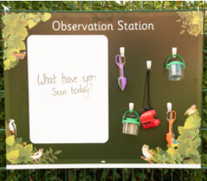
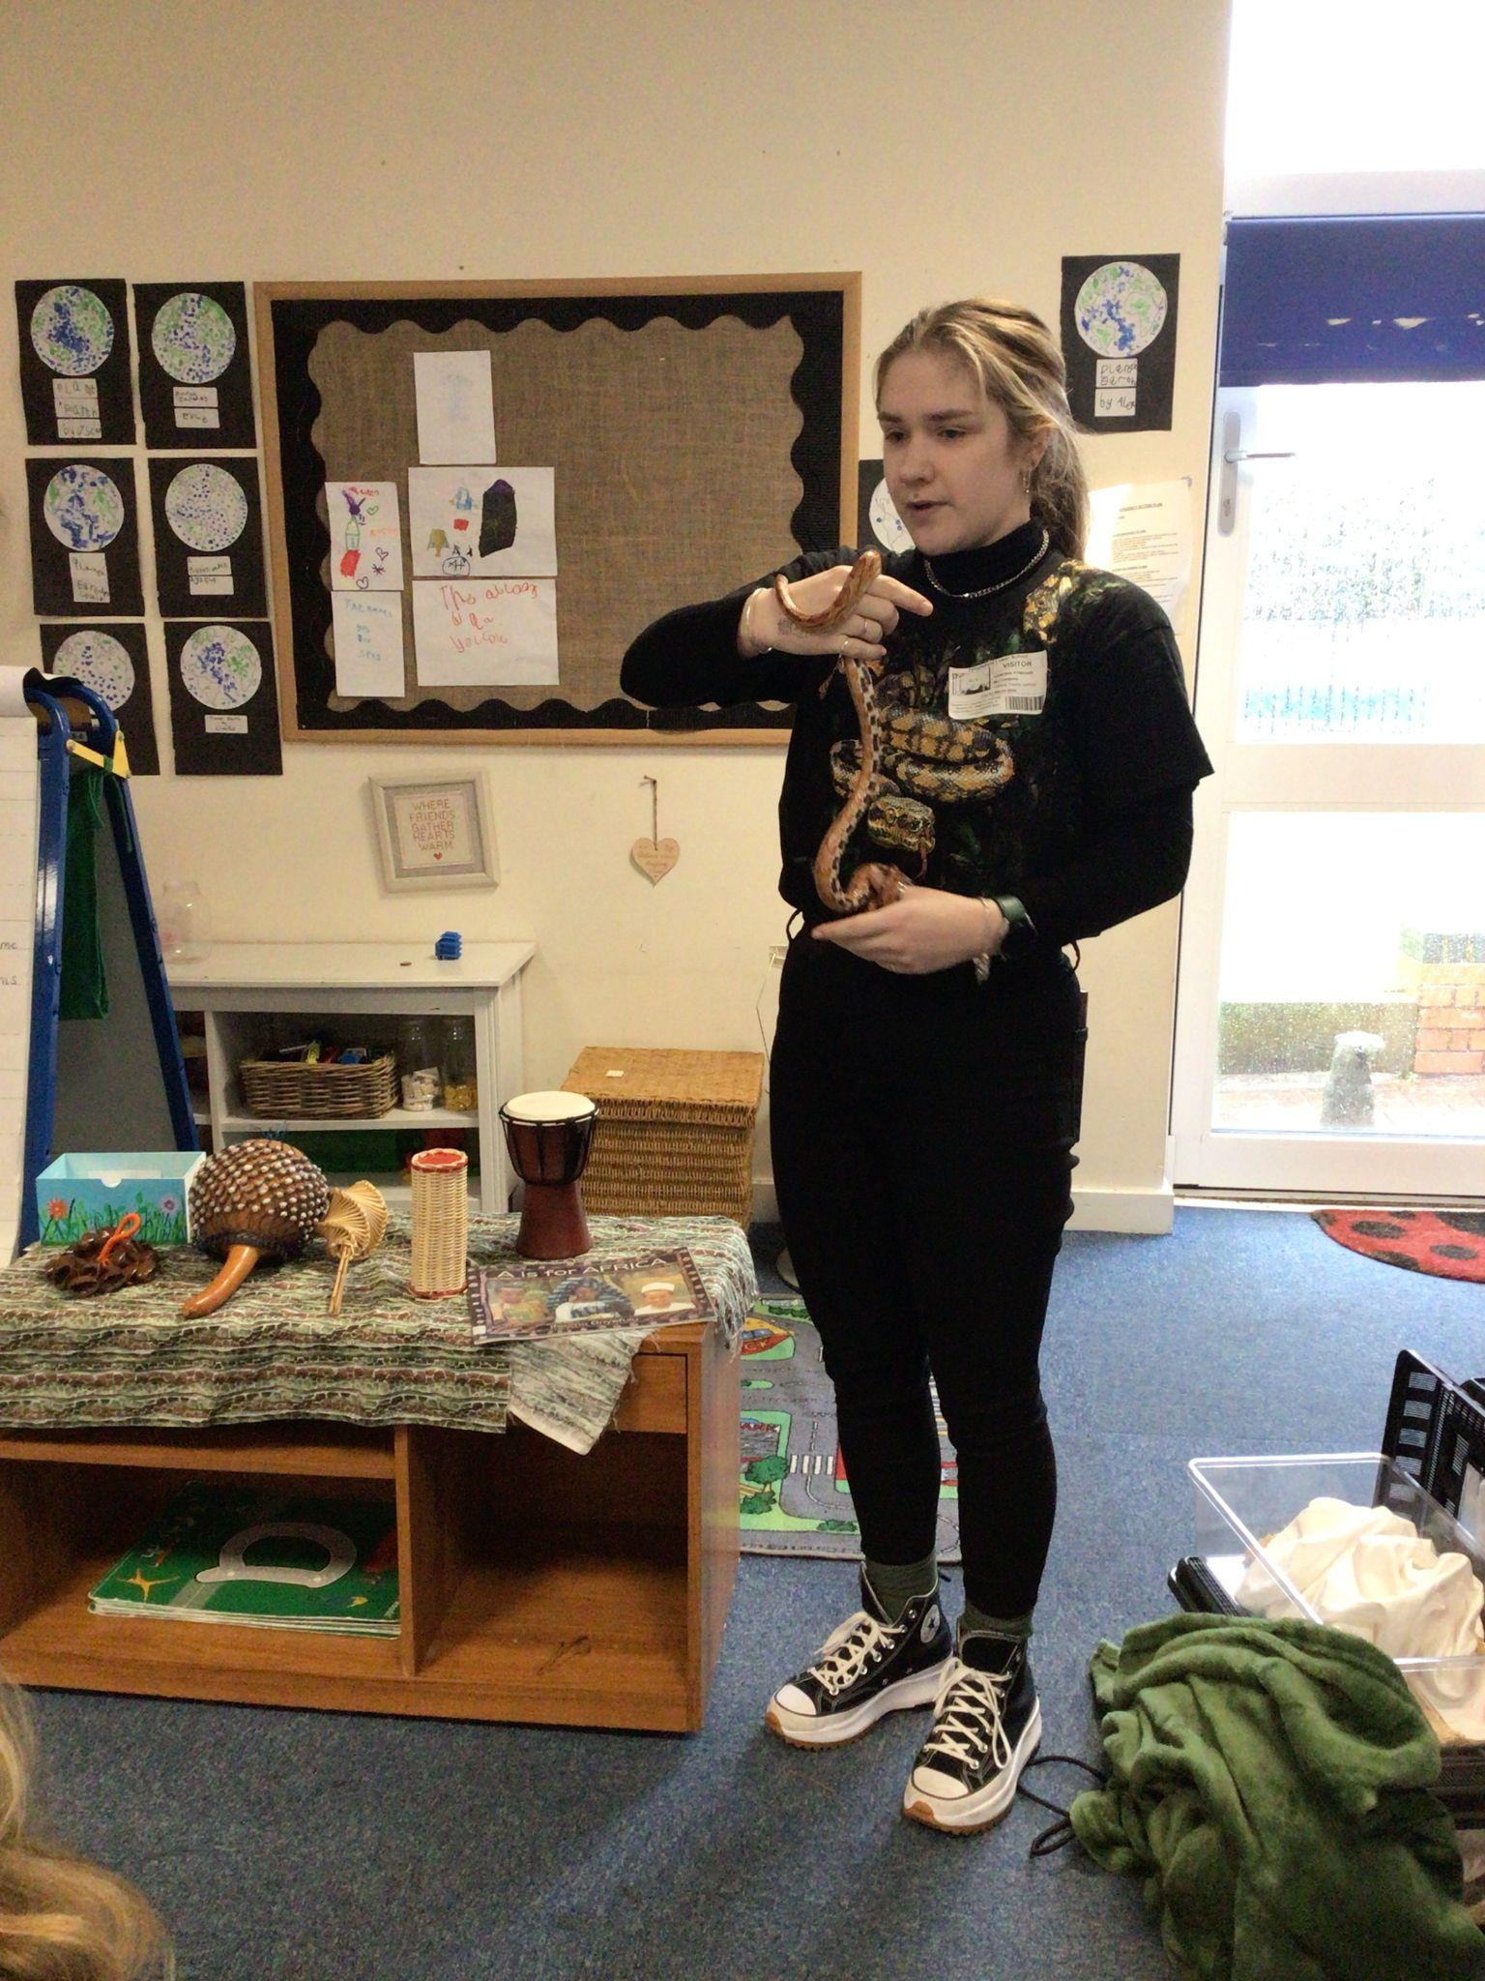
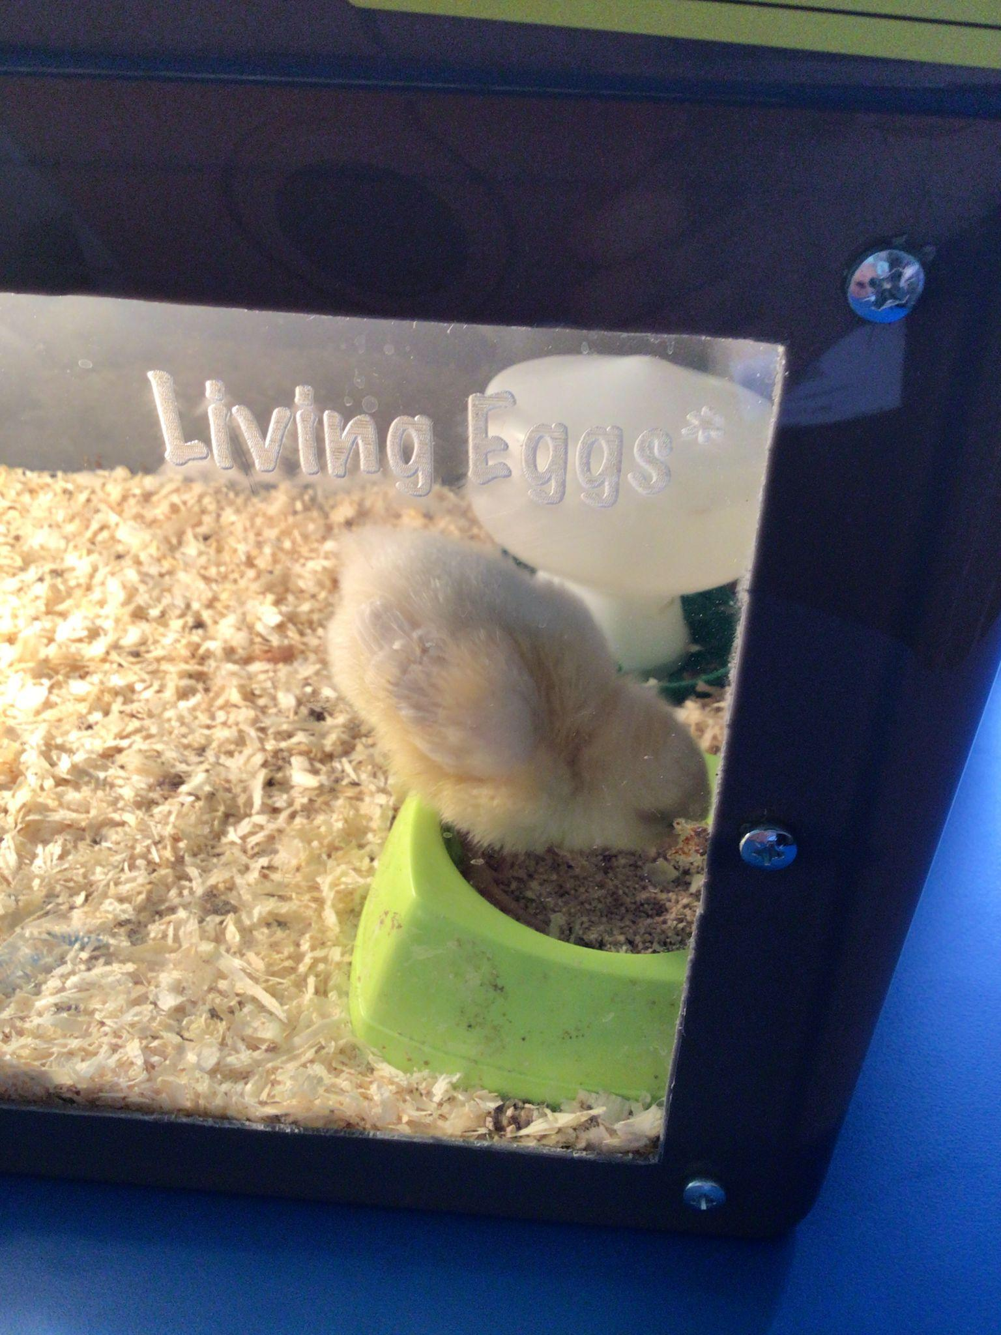
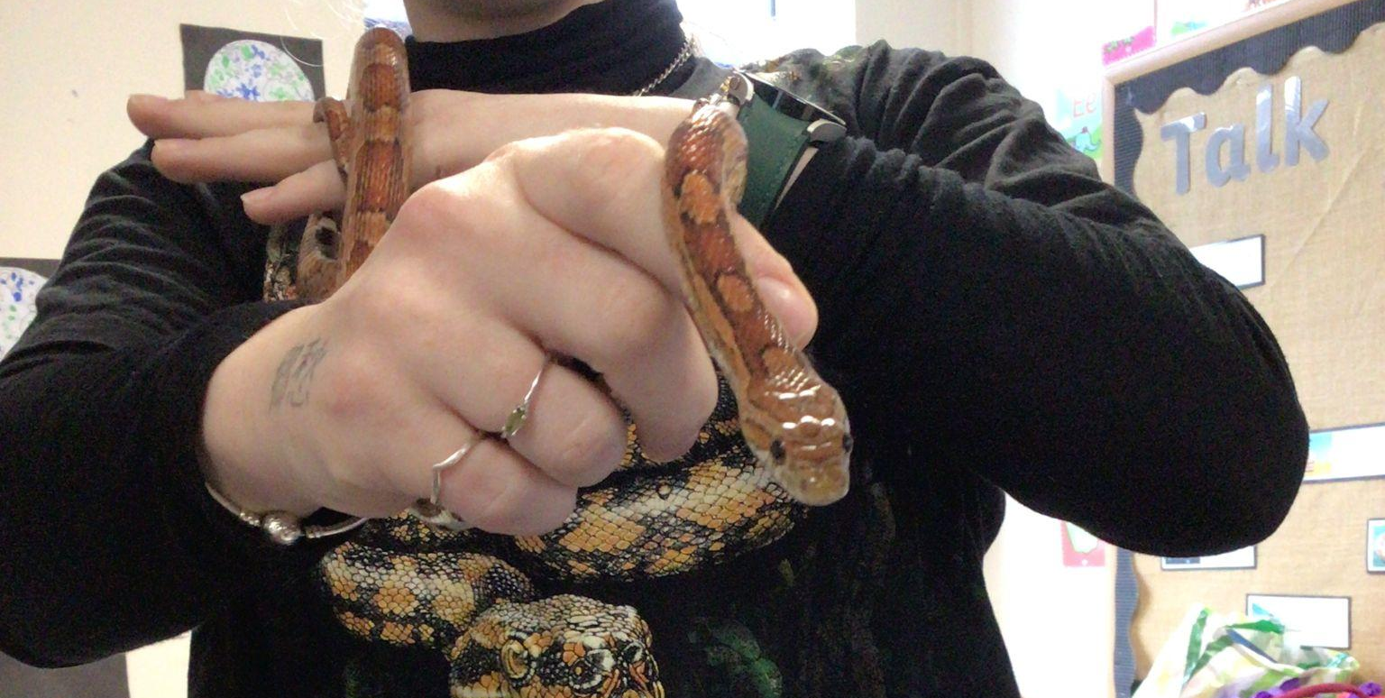
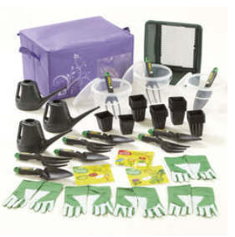
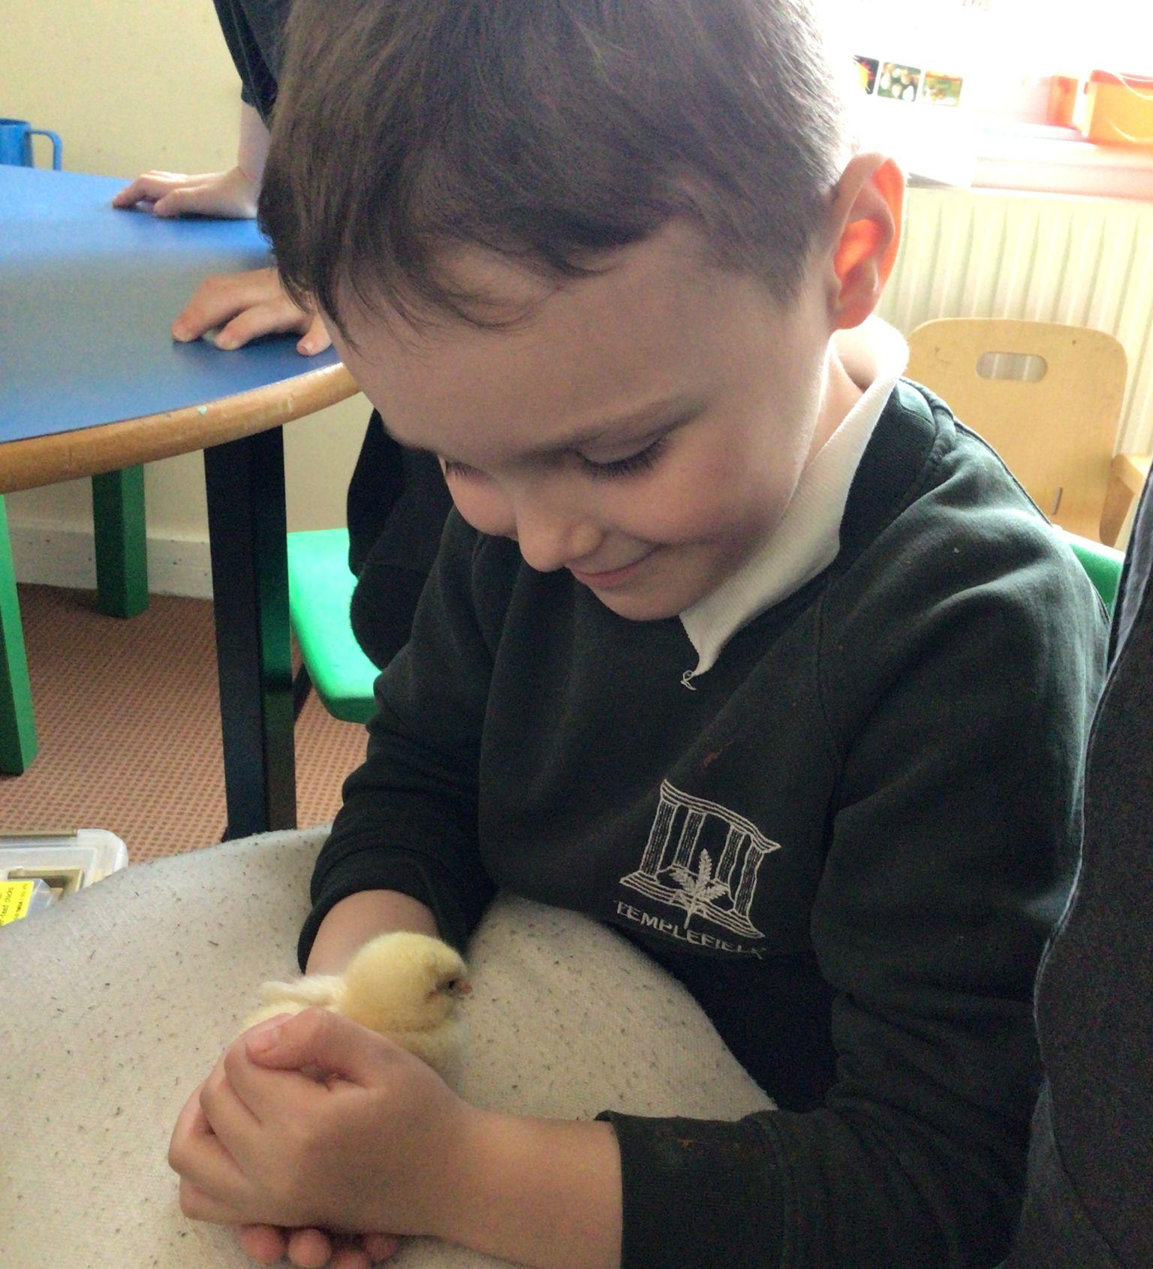
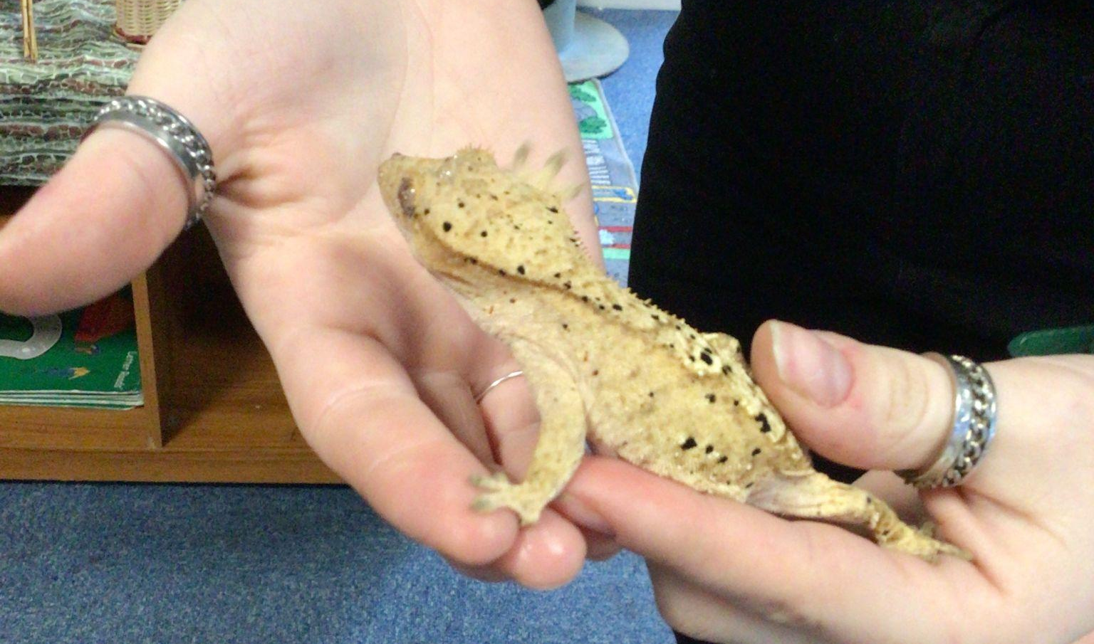
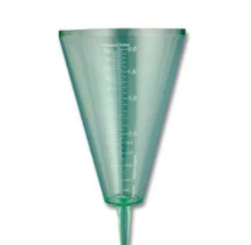
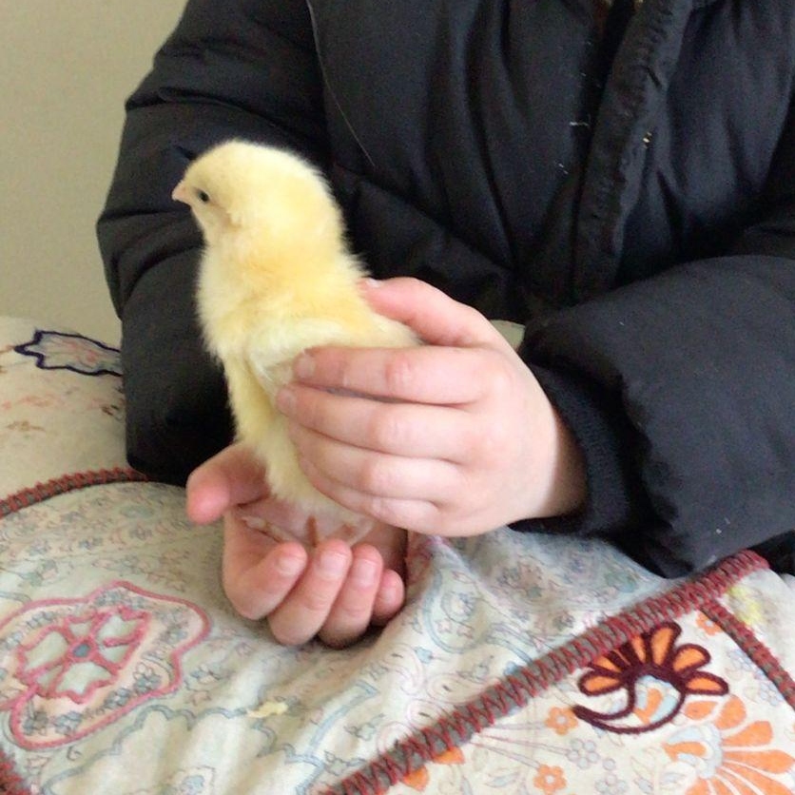

‘Living Eggs’ in Foundation
Funding for Science equipment
We would love to update our outside area with lots of scientific equipment such as thermometers, rain gauges, observation station, outdoor posters, gardening kits.
Please do let us know if you / your company are able to support us in raising these vital funds.
Do we have any scientists among us?
Templefield Lower School would love to welcome anybody working in STEM related jobs to come and talk to the children about their work, either in assemblies or through workshops. Please get in touch if you feel that you could give a little time to support our Science capital!
“I held a chick and it was soft! They came in eggs and we put them in an incubator. There were boys and girls.” - Foundation child
This term in Preschool we are learning how to become an exceptional explorer by showing curiosity in the world around us!
This term in Early Years we are learning how to become an exceptional explorer by showing curiosity in the world around us!
This half term in Year 1 we are learning about common animals including fish, amphibians, reptiles, birds and mammals.
This half term in Year 2 we are learning about what plants need to grow from a seed into a mature plant.
This half term in Years 3 and 4 we are learning about solids, liquids and gases, and how materials change state when they are heated or cooled.
BRITISH SCIENCE WEEK 2024 – What did we get up to?
During British Science Week, Foundation and Year 1 had a visit from a zoologist! She brought a gecko, corn snake and a scorpion.
The children talked about what all animals need to survive and live healthy lives. Tanesha explained how to care for these specific animals, including what they ate, their habitats and hygiene.
What is a scientist?
Scientists are people who discover new things and research how things work.
Scientist of the term
Maggie Aderin-Pocock - space scientist

