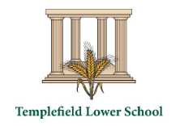
Science Newsletter
Spring 1 2025

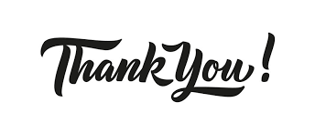Thank you so much to everyone who has contacted me regarding visits to Templefield Lower School to share your scientific expertise Children from across the school are going to have such an amazing time in the Spring term!
This term in Preschool we are learning how to become an exceptional explorer by showing curiosity in the world around us!
This term in Early Years we are learning how to become an exceptional explorer by showing curiosity in the world around us!
This half term in Year 1 we are learning about seasonal change through observation and description.

This half term in Year 4 we are learning about plants, including water transportation and the different parts of a plant.
This half term in Year 3 we are learning about light, reflections and shadows.
This half term in Year 2 we are learning about the basic needs of animals and humans including the importance of exercise, food and hygiene.

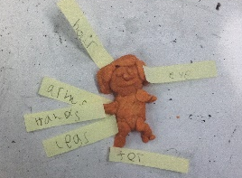
Year 1: exploring body parts
Year 1 children have been exploring and naming body parts. They have made some fantastic models of the human body!
Dates for your diary
April – Scientist visit to Year 4 (TBC)
22nd April – Earth Day
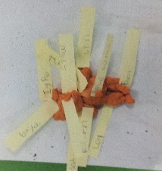

Year 2: cross-curricular writing
Year 2 children have worked really hard this half term to apply their Talk for Writing skills to their Science learning.

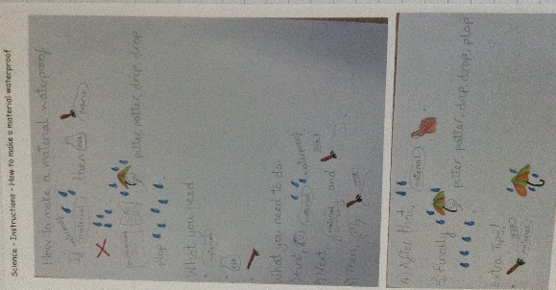
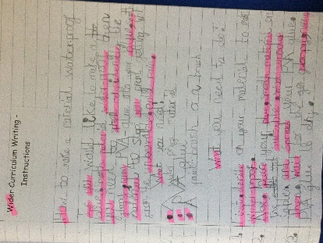
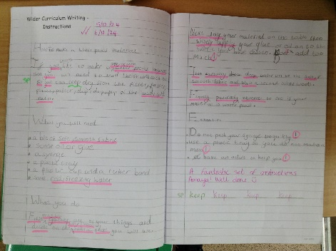
What is a scientist?
A scientist is a person who is studying or has expert knowledge of one or more of the natural or physical sciences
Scientist of the term
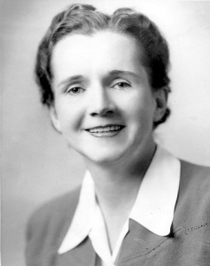
Rachel Carson – environmental pollution and history of the sea.
Science History
Did you know that astronomy is considered the oldest Science?

