
Science Newsletter
Autumn 2 2024

Funding for Science equipment
We would love to update our outside area with lots of scientific equipment such as thermometers, rain gauges, observation station, outdoor posters, gardening kits.
Please do let us know if you / your company are able to support us in raising these vital funds.
Do we have any scientists among us? 
Templefield Lower School would love to welcome anybody working in STEM related jobs to come and talk to the children about their work, either in assemblies or through workshops. Please get in touch if you feel that you could give a little time to support our Science capital!
This term in Preschool we are learning how to become an exceptional explorer by showing curiosity in the world around us!
This term in Early Years we are learning how to become an exceptional explorer by showing curiosity in the world around us!
This half term in Year 1 we are learning about senses and body parts.

This half term in Year 4 we are learning about rocks and soil.
This half term in Year 3 we are learning about animals including humans.
This half term in Year 2 we are learning about materials.

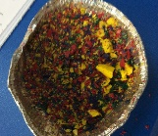
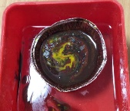
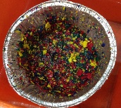

Dates for your diary
24th – 26th January 2025 – RSPB Big Garden Birdwatch
7th – 16th March 2025 – British Science Week
20th March 2025 – ‘Plant Your Pants’
Year 3: rock types
In year 3, the children have been exploring sedimentary, metamorphic and igneous rocks. They squashed and melted crayons to represent the different rock types.

What is a scientist?
Scientists are people who use evidence and research to understand the world and discover new things.
Scientist of the term
Stephen Hawking 1942-2018 worked on the physics of black holes.

Science History
Did you know that historian and philosopher of Science, William Whewell, came up with the term ‘scientist’ in 1834?

Year 4: cross-curricular writing
Across the school, we have been implementing cross-curricular writing opportunities within Science. Year 4 showed their skills in writing an information text about magnets and forces.

